Black Ant Instant Male Enhancement Female Aphrodisiac

BLACK ANT:
Traditional Recipe Improved by Modern Bioengineering Technology
For centuries Chinese herbalists have known that the Black Mountain Ant (Polyrhachis vicina Roger) has an unparalleled ability to treat rheumatoid arthritis, lumbago/back pain, increase energy levels, decrease muscle pain after exercise, and enhance sexual potency. bLACK ANT eNHANCEMENT
BLACK ANT has been launched to market after successful clinical experiments. It has a remarkable and lasting effect on hormonal activity, activates adrenal gland, stimulates and improves body's immune system and improves sperm and fluid production. In turn it significantly increases sex desire (libido), induces and improves erection for men and vaginal secretion for women. Regular usage has remarkable rejuvenating effects.
- Ingredients: Polyrhachis vicina roger (Black Ant), Formica Sanguinea, Ginseng (root) Hippocampi, Medlar, Proprietary Blend of Essential Amino Acids and Trace Minerals.
- Black Ant has NO harmful side effects and its regular usage can improve overall health.
- Black Ant is taken orally and is absorbed through the lymphatic system, bypasses the liver and thus does not affect the liver function. bLACK aNT mALE eNHANCEMENT
- Usage: Take one capsule and swallow with a bit of liquid (best warm water) about 30 minutes before sexual intercourse. Do not take more than one capsule within 24 hours period. If the erection(s) persists or becomes longer or more frequent then desired it could be brought down by drinking cold water repeatedly.
**We only offer Top Quality ORIGINAL BLACK ANT**
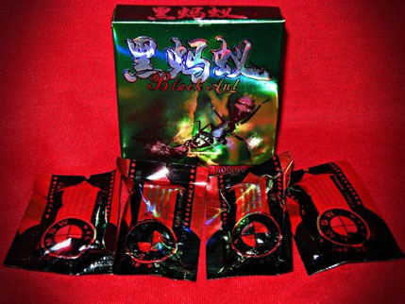
For More Info Contact at 396-0316, email: frassout@gmail.com , Blackberry Pin 22298698

